“Smash Squad” Game Evaluation and Console Game Development Industry Evaluation
  - By: Thomas JEBSON (24804704)
Contents
“Smash Squad” Game Evaluation and Console Game Development Industry Evaluation 1
1. Abstract 1
2. Console Development Practices 1
3. Digital Storefronts 3
4. Console Market Share 3
5. Game Evaluation 4
References 10

Abstract
This academic report focuses on a review of the console game development industry and on the 3D game ‘Smash Squad’, which was developed specifically for this assignment using Unity 6000.0.58f1 (Unity Technologies, 2025). This game is designed specifically for the Xbox Series S (Microsoft, 2025) using the Universal Windows Platform (Microsoft, 2024).

Console Development Practices
Microsoft initially released the Xbox Series S on the 10th of November, 2020 (The British Broadcasting Corporation (BBC), 2020), for £349.99 (Microsoft, 2025) alongside the Xbox Series X, which at £449.99 (Microsoft, 2025) is the more powerful of the two devices when comparing the all-digital versions of both consoles in the same one-terabyte storage option. This was the fourth generation of Xbox hardware released by Microsoft (The IGN, 2025). The Xbox Series S does not feature a version with a disk drive, making it only compatible with digital-only games (The IGN, 2025).
For each generation of Xbox hardware, there were both consumer versions and game development kits, which were not intended for the public to use. These game development kits were distributed to developers once the target hardware was decided upon, but before the release of the consumer devices, so that games could be developed specifically for this platform and be available at launch. Non-Disclosure Agreements (NDA’s) are used by Microsoft (Microsoft, 2025) to stop details of these devices from being released publicly as a precaution to prevent competitors like Sony from releasing competing devices in the run-up to the console’s launch. This means there is little information available about the Xbox Series S development kit.
What little is known about the Xbox Series development kits is that Microsoft recently increased the price of the unit from $1,500 to $2000, and that the console features “significantly more memory” than its cut-down and more affordable consumer counterpart, with also more extensive debugging features (GamePressure, 2025).
There is a ‘developer mode’ for the Xbox Series S that allows people to develop games for this platform if they can’t afford the official Xbox Series S development kits. The Xbox One (the previous Xbox console generation) requires the user to sign up for an Xbox developer account for $19 (Polygon, 2016). This developer mode, however, has a caveat: all the applications and games you create for it must use the Universal Windows Platform rather than run natively on the device.
This ‘developer mode’ application for the Xbox Series S from Microsoft is a unique approach to lowering the entry bar for smaller game studios to just $19, with no need to sign a non-disclosure agreement. Competing companies like Sony and Nintendo both require the use of a development kit and, consequently, the need to sign a non-disclosure agreement before any game can be developed for their platform. Whilst information about Sony’s latest console development kit for the PlayStation 5 is not publicly available, their development kit for the PlayStation 4 is “around $2,500” (ORBISPatches, 2026) considerably more than the cost of the consumer variant, which is $349 (GanmeRant, 2024). Sony does offer the option of renting the PlayStation 5 development kit to support smaller studios; however, the same legal process remains (GamesHub, 2022). Nintendo’s development kits for the Nintendo Switch are more affordably priced at $450 (ORBISPatches, 2026) however, also requires a registration process (Nintendo, 2026).

The Universal Windows Platform was an initiative by Microsoft that was introduced with the operating system Windows 10 to enable applications to be made once and be built to run on a variety of different platforms, ranging from Windows 10 and Windows 10 Mobile through to consoles like the Xbox Series S. This approach enabled developers to build their apps and publish them on the Microsoft Store, a digital marketplace where both games and applications can be downloaded for various Microsoft platforms.
The Universal Windows Platform, however, operates as a walled garden, meaning that game distribution across devices is primarily controlled by the Microsoft Store. This can make it harder for studios to distribute their games due to a strict publishing guide (Pure Xbox, 2025). However, Microsoft recently made its publishing guide publicly available, a move designed to make it easier for studios to publish games on this platform. But these publishing guidelines also ensure that distributed software is more secure (Microsoft, 2024), rather than being released through unofficial download sites, which may contain malware. Additionally, Microsoft’s walled garden ecosystem here is beneficial to consumers, as it helps to simplify the installation process for new software by closely integrating this process into the Microsoft Store, instead of having to navigate through custom installation utilities and installing additional dependencies like graphics application programming interface runtimes or Microsoft Visual C++ Redistributable.
Furthermore, the Universal Windows Platform has strict limitations; there is a maximum executable size of two gigabytes, and it limits games to only use four exclusive and two shared central processing unit (CPU) cores (TechRepublic, 2020). This means that, for the Xbox Series S, which features an eight-core central processing unit, the game cannot fully utilise all available hardware. These constraints make it impractical for some studios looking to make games using this build method, as “while indie games might only need a few gigabytes, massive AAA games can take over 100GB of capacity each” (Seagate, 2025).

Due to the Xbox Series S’ diskless design, there is a requirement for the distribution of games to be done through Microsoft’s own digital marketplace, meaning that Microsoft gets a 12% cut of the profit when a product is purchased (PC Mag, 2021). This could create pricing pressure on game studios, as Microsoft would hold a monopolistic position as the only distributor of games on this platform. Additionally, the Universal Windows Platform only supports specific Microsoft platforms, so significant re-development is needed to allow games to run on alternative or competing platforms. Take the Android platform, for example, which uses Google Play as the digital marketplace (Google, 2025). When porting a personal computer or Universal Windows Platform game over to Android, “a lot of time, money and effort” is needed as further optimisation, changes to the input system, as well as considerations into the range of assets and supported resolutions are needed (Pingle Studios, 2021).
In October 2021, Microsoft announced the deprecation of the Universal Windows Platform and said that it would only now get “bug, reliability and security fixes” (Thurrott, 2021) which throws into doubt whether the Universal Windows Platform will be supported in a similar way in future Xbox console generations as it is in the Xbox Series S and previous generations. Furthermore, it raises concerns that this platform will lose out on new features like updated graphics application programming interfaces (APIs) or hardware integration support for components like neural processing units, which is “poised to be a game-changer for enthusiastic gamers” (Techovedas, 2024).

Digital Storefronts
With the exception of the Xbox Series S, all other Xbox console models have supported disc drives or had a variant with one. This means game companies can distribute their games on physical media to physical shops, instead of relying on downloading games from online marketplaces. This has the advantage of being more consumer-friendly, allowing people to share or resell the disks once they have finished playing the game and also means there is less reliance on external servers to be online to install and play games.
The Xbox Series S does not have a model supporting a disc drive (The IGN, 2025). Therefore, all games you can install on this platform must come from the Microsoft Store, as it is the only supported digital storefront. This reduces competition from other digital marketplaces, like, for example, Steam (Valve, 2026), and gives Microsoft the ability to determine its own pricing, with consumers having nowhere else to shop around. Furthermore, it prevents the resale of games and leaves the platform vulnerable to Microsoft dropping support in an attempt to force people to upgrade to a newer console.
Microsoft also has a system called ‘Xbox Game Pass’ that lets you pay a monthly subscription to play a variety of games. This system means players do not own a copy or a license to play the game, and must continue paying to play it or buy it outright. This service has divided the games industry, with some studios being firmly against it, with Raphael Colantonio, founder of Arkane Studios, stating, “I think Gamepass is an unsustainable model that has been increasingly damaging the industry for a decade” (Polygon, 2025). Meanwhile, Mike Rose – founder of the independent publisher No More Robots – has “made a point of talking publicly about how Game Pass has helped his own company’s games” (GameSpot, 2023).

Console Market Share
The Xbox Series S has a starting price of £299.99 (or $399.99) (Microsoft, 2025) which is reported to be around $100 less than the total cost of the components (PC Mag, 2022). This approach is taken as Microsoft’s strategy is to make up the difference and turn a profit through the additional revenue of the end user needing to buy games for the device (PC Mag, 2022) from Microsoft’s digital marketplace. This makes the Xbox Series S a more attractive purchase over a “slightly more powerful” personal computer, which would “cost users just under $610” (Sportskeeda, 2023). It should be noted that Microsoft isn’t using ‘off-the-shelf’ computer components in the Xbox Series S, so a direct comparison between hardware isn’t possible.
“The global gaming console market size was estimated at USD 26.32 billion in 2024 and is projected to reach USD 47.58 billion by 2033, growing at a CAGR [Compound Annual Growth Rate] of 6.7% from 2025 to 2033” (Grand View Research, 2025). This indicates that whilst the console gaming market is growing, it remains the smallest of the three main contributors to the overall gaming market evaluation.
“The global gaming PC [personal computer] market size was estimated at USD 61.84 billion in 2024 and is projected to reach USD 129.93 billion by 2030, growing at a CAGR [Compound Annual Growth Rate] of 13.5% from 2025 to 2030” (Grand View Research, 2025). This demonstrates that the personal computer gaming market is 80.58% larger than the console gaming market, based on their 2024 estimates, and is also growing at a faster rate of 13.5% from 2025 to 2030, compared to the 6.7% for console gaming in the same time period.
However, “the global mobile gaming market size was estimated at USD 139.38 billion in 2024 and is projected to reach USD 256.19 billion by 2030, growing at a CAGR [Compound Annual Growth Rate] of 10.2% from 2025 to 2030” making this the largest share of the total gaming market estimated value. There are two primary reasons why the mobile gaming market currently has a similar market value as the console and personal computer markets combined: Firstly, as of 2025, there are an estimated 4.69 billion smartphone users globally (Statistica, 2025) which is 103% more than the estimated 1.4 billion personal computers running Windows (Tom's Hardware, 2025) and 100.4 million Mac users (SpyHunters, 2025) combined. Secondly, the average price of a mobile game is between $0 and $5, which is much lower than the $40 to $60 average for a personal computer game and $60 to $70 for an Xbox Series S/X game. These factors combined mean the mobile gaming market has the lowest barrier to entry.
In conclusion, the global console gaming market is the smallest of the three largest markets in this industry. With the cost of buying a personal computer set to “continue to rise through next year”, according to Kingston executives (Ars Technica, 2025). Console gaming is looking like an increasingly more affordable option for people looking for platforms to play games that can’t be run on lower-end mobile devices. Further to this, games made using Microsoft’s Universal Windows Platform can be targeted at both console and personal computer gaming markets without the “time, money and effort” required to port a game over to Android (Pingle Studios, 2021). However, building native games to any console platform is a costly endeavour – requiring the need for a development kit, which can put native Xbox game development out of the reach of smaller studios which would likely target the personal computer or mobile platforms for their larger audiences and lower cost of entry with one game maker stating: “If you need to spend USD $20,000 out of pocket to port and get on a platform, you have to hope to make more than that to just break even – and that’s not even factoring in time” (Patreon; Skill Up, 2024).

Game Evaluation
To best evaluate how well this game project went, verbal feedback was collected through informal playthroughs with other class members and lecturers. The feedback received was generally positive, with people able to quickly understand the game's objective. One of the areas people generally seemed to enjoy most was the array of different mechanics that could be used to knock the opponent off the map. In this game, the player is able to directly hit the opponent, shoot the opponent with a ranged attack to deal significant knockback, or use their selected character’s special ability to change up some of the mechanics of the game. In this game, the player can choose from four characters, each with a unique special ability. The menu showing these options is shown below:
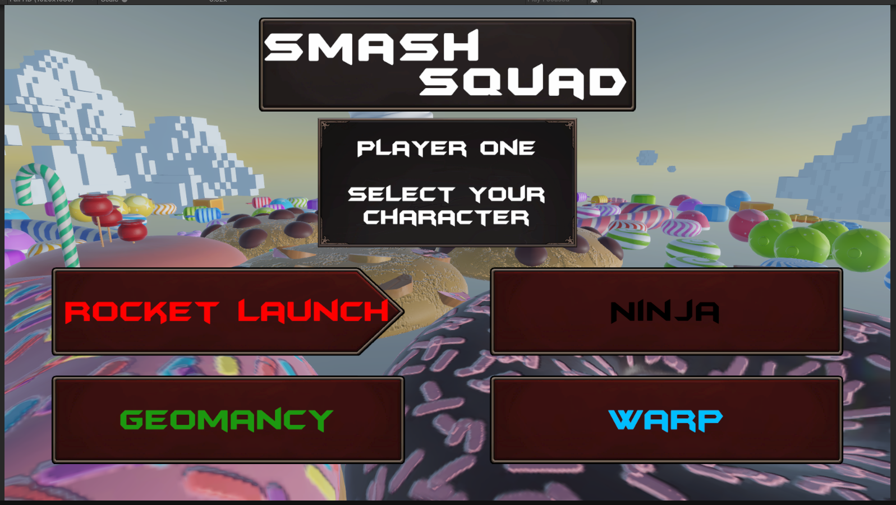
Figure 1: A screenshot from the game ‘Smash Squad!’ Showing the ‘class selection menu’ for player one. There are four different characters to choose from.
The Rocket Launch character creates a large explosion at their feet, causing them to be thrown into the air and neighbouring players to be knocked back. The Ninja character can turn invisible and can be used to sneak up on other players undetected. The Geomancy character can spawn an island below their feet and use it to walk easily between islands – or they can jump off and attempt to knock it into the other player to knock them back. Finally, the Warp character can throw a projectile and be teleported immediately to where that projectile lands on the map. These special abilities are effective at creating a wide range of gameplay strategies, and the game's physics-driven nature allows players to experiment with new uses for the tools at their disposal.
This game was developed with an Xbox controller being used as the only input device. This input device includes a variety of input options. The ranged attack uses the analogue triggers to mimic drawing back a bow, being able to adjust their range by changing how much they press the trigger. The axis inputs (the left and right joysticks) are used to pan and move the character, and the buttons are used for binary actions like attacking or jumping. The Xbox controller also has rumble functionality, which is used extensively in the game to provide feedback to events happening on-screen, like an explosion occurring in the player’s vicinity. A key design decision made when developing the game was to combine the hints on which buttons to press with the heads-up display. The heads-up display shows the inventory quantities of certain items, such as arrows, that the player can fire. Items with limited quantities will gradually restock over time, and only 5 of these items can be stored, adding constraints the player may need to consider when planning their next move. The revised heads-up display with the button prompts is seen in the image below:
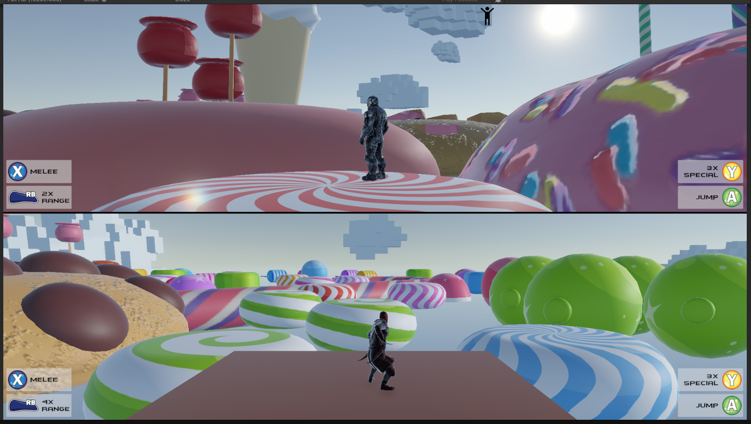
Figure 2: A screenshot from the game ‘Smash Squad!’ Showing the game’s heads-up display with integrated controller hints.
One of the primary challenges when developing this game was ensuring it ran within the 40-60 frames per second target seen in other games in this genre. This game is targeted specifically for the Xbox Series S platform and uses Microsoft’s Universal Windows Platform instead of an Xbox development kit because it has a lower setup cost. However, by choosing this build approach, the game cannot use all the device's available hardware, and as such, its design needed careful consideration to ensure the frames-per-second target could be reached.
As a direct consequence, the strategy for this game was to optimise on the fly rather than as a later step after the game mechanics had been created. This means the game's optimisation could directly influence its overall design, as seen in the map's construction. Originally, the map consisted of approximately 60 individual models combined into a single prefab; however, this resulted in an average of 33.7 frames per second in a release build on the Xbox. To address this, the individual models were combined into a single monolithic model, and testing this approach yielded an average frame rate of 73.8 on the Xbox, exceeding the targeted 40-60 frames per second. However, this had a knock-on effect on the mechanics of the fireball. The game starts spawning fireballs to rain down on the map after the current play-through of the game has exceeded two minutes in duration. The idea here is that they add challenge to the game, making it harder for a player to win. The original idea was for the fireballs to destroy some of the surrounding smaller islands on the map, shrinking the overall play area and forcing the players into closer proximity. With the map being optimised into a monolithic model, this approach was no longer possible as the map couldn’t be changed. To address this, the fireballs were given a stronger knockback effect against the player, and the end result remains effective at increasing the game's difficulty.
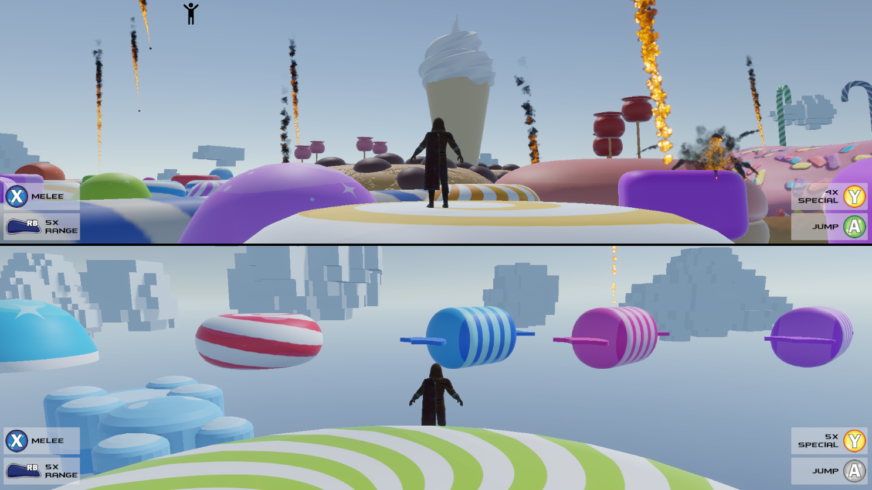
Figure 3: A screenshot from the game ‘Smash Squad!’ Showing the fireball mechanics.
In addition, clouds were introduced to the 3D environment as additional decoration; however, during testing, their behaviour of spawning in and gradually decaying through scale adjustments resulted in a noticeable 13.2% drop in performance during a two-minute idle test. This occurs because whenever the scale changes, Unity’s vertex batching pipeline needs to be reconstructed for cloud rendering, a costly process. To mitigate this issue, a technique called ‘temporal delayed updates’ was used to spread out updates for lower-priority features, such as clouds, across multiple frames rather than updating them every frame. This is possible because these objects are not critical to the overall game and can lower frame drop caused by adding cloud mechanics from 13.2% to 5%. This is a mechanic that had been explored in other projects but was used very effectively here and will be considered more aggressively as an optimisation strategy in future projects.
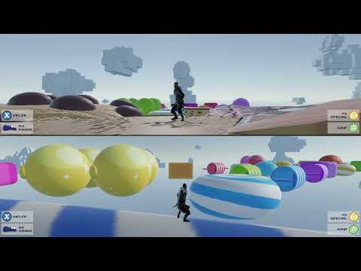
Figure 4: A video from the game ‘Smash Squad!’ Showing the clouds moving using ‘temporal delayed updates’. This video has been sped up to six times normal speed. Please note that embedding the YouTube video was the only way to include it. If not viewable, the video is also available here: ‘https://youtu.be/XgjbmgsRsbY’.
The second challenge encountered in developing this game was creating a local multiplayer system. Initially, the expectation was to assign a specific input device to an event system, or to the player’s character and then use the new input system to program the functionality for input events from there. However, in practice, this turned out not to be the case; instead, a system was developed using Unity’s Gamepad application programming interface, where the game would listen for a controller interaction to assign it to a specific player, then use that player's inputs. This system worked in-game, but had consequences for other menus. Most notably, when using a menu’s event system and targeting a specific device to listen for inputs, the input system would break and needed to be told which input action references corresponded to which input actions in the event system. This was a challenge to get working, but after exploring the intended approach in Unity, there doesn’t appear to be a solution that would have covered both the 2D menu and the 3D game's per-controller input without its own challenges.

Overall, my experience working on a game for the Xbox Series S has been positive. By developing a game using the Universal Windows Platform, there was a clear, finite performance budget for games running on the device, which meant additional optimisation was needed to maintain good game performance. This is in contrast to the personal computer platform, where machine specifications are not uniform, and there is often an expectation that the end user needs a more powerful device to run the game at its best. Additionally, whilst extra steps are required when building and installing Universal Windows Platform games on the Xbox, the process has been straightforward and didn’t require any additional hardware. This is in direct contrast to building iOS games, where the game must be built for a specific device in Xcode on Apple-specific hardware, considerably complicating the process and increasing the upfront cost, as a Mac is needed to compile the game for the target iOS platform. It is disappointing then that Microsoft isn’t looking to continue adding new features to the Universal Windows Platform, as the added benefit of being able to test a build on a personal computer when there isn’t an Xbox to hand was very useful – and I could see it being useful also for smaller studios that might not have the budget for buying a console for each member of the team to test on.

After extensively playing through the game myself, the feedback received is fair, and the criticism of there not being more maps is balanced by the size of the ‘Candyland’ map provided and the philosophy that having more mechanics, like the character power-ups and ranged attacks, provides more overall value to the game with the time constraints applied. Looking back at the brief for this assignment, the game ‘Smash Squad’ does a good job of meeting the outlined criteria, as it is “entirely controlled by an Xbox controller” and a “complete prototype”. Further, support for some accessibility controls, such as the ability to invert the axis for camera controls, helps make the game available to a wider audience.
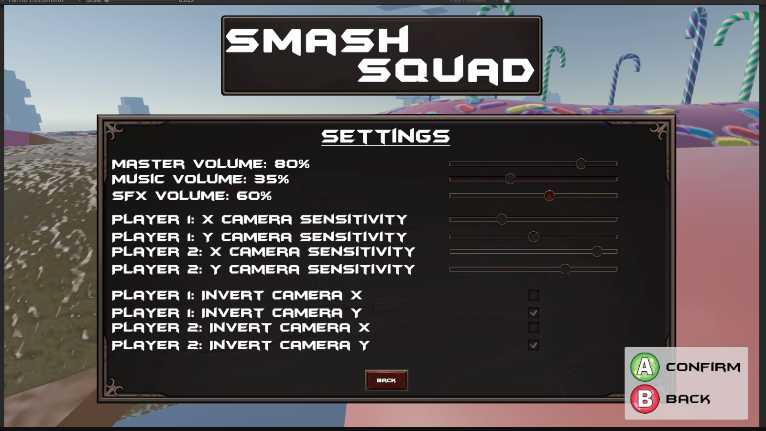
Figure 5: The settings menu for the game ‘Smash Squad’ featuring some accessibility controls.
There are, however, some key areas that could be improved upon in future versions of the game. Firstly, this is my first implementation of local multiplayer, and whilst it works well in this game, the approach used is inflexible for adding more players in the future. This isn’t a primary concern for this game as if it remains Xbox Series S exclusive, with each additional player added to the game, the entire game scene needs to be re-rendered again, which with the limited budget provided by the Universal Windows Platform build strategy and generally low-cost hardware seen in the Xbox, would result in a noticeable degradation in the performance of the game. Despite this, it provides a platform for future implementations of local multiplayer to improve in other games.
Another area of the game that could be improved is its sound implementation. When first drafting a plan for the game, the idea was for each player to connect headphones to their controller and hear only what their player in the game could hear. However, Unity only allows for there to be a single audio listener active in the scene, so this approach wasn’t possible. Instead, both players hear the same sounds, and there is no panning of sounds to reflect where in the game’s 3D environment the sound is coming from. This appears to be more of an engine limitation, and it was beyond the scope of this project to investigate a solution further.
Additionally, whilst the game uses a variety of different input options present on the Xbox controller, there is a notable absence of the hat (or d-pad), which serves no purpose in this game at this time. This is due to the project's limited scope for adding functionality. If the game were to be developed further, the hat buttons would likely be used to add the ability to access different weapons or special items collected from around the map, such as smoke grenades or weapons with increased knockback or reach.
Finally, when developing the idea for the game, inspiration was drawn from other games, most notably ‘Super Smash Bros. Ultimate’ (Nintendo, 2026), where players engage in battles with exaggerated physics and extensively utilise their selected characters' special abilities to gain the upper hand over their opponents. This theme is also evident in the developed game for this assignment. However, there are also clear differences in the game's style: Smash Squad is a third-person game set in a more expansive 3D environment. Furthermore, an early concept of ‘Smash Squad’ used a similar principle to the Minecraft map ‘Blast Off’ (NecoMc, 2026), where players would battle on a floating island, using explosives to make holes in the map and tools that provided knockback to try and knock the opponent off the map, in doing so winning the game. This idea would be reworked somewhat, as changing the geometry of a 3D model in Unity to represent an explosion was beyond the scope of this project. In this Minecraft map, there is a class called ‘rocket jumper’ that launches the player into the air and knocks back nearby opponents. The developed game Smash Squad has a character called ‘Rocket Launch’ that was directly inspired by this. Ultimately, concepts from both ‘Super Smash Bros. Ultimate’ and the Minecraft map ‘Blast Off’ were used as inspiration for the game, alongside the playground game of ‘king of the hill’ (where players would attempt to remain on top of a raised point, whilst others would try to pull you off (The Dihedral, 2021)) to produce a video game with a unique gameplay experience.
This game uses the Universal Windows Platform as it’s build strategy. This means that if the game's development continued beyond this point, it would also be made available for other operating systems beyond the Xbox Series S, as the build strategy would allow it without needing to recompile the game for each operating system in the Universal Windows Platform ecosystem. However, doing this would warrant careful consideration of how other devices running this game would perform. For this reason, the settings menu would be updated to include controls for adjusting the game's graphical fidelity. Additionally, the game’s local multiplayer system would be reworked to support more than just two players, while the same multiplayer strategy currently used would be broadly retained. Finally, more maps and animations for the characters would be added, as they had to be removed from the scope of this project due to timing constraints.

References
Ars Technica, 2025. RAM and SSD prices are still climbing—here’s our best advice for PC builders. [Online]
Available at: https://arstechnica.com/gadgets/2025/12/for-just-a-couple-of-months-in-the-middle-of-2025-it-was-an-ok-time-to-build-a-pc/
[Accessed 19 December 2025].
GamePressure, 2025. Xbox Series X/S dev kits increase in price. Microsoft can't seem to get a win. [Online]
Available at: https://www.gamepressure.com/newsroom/xbox-series-xs-dev-kits-increase-in-price-microsoft-cant-seem-to/zb87e7
[Accessed 17 January 2026].
GamesHub, 2022. https://www.gameshub.com/news/news/playstation-free-ps5-dev-kits-for-indie-creators-developers-publishers-24977/. [Online]
Available at: https://www.gameshub.com/news/news/playstation-free-ps5-dev-kits-for-indie-creators-developers-publishers-24977/
[Accessed 17 January 2026].
GameSpew, 2018. Mobile vs Console and PC Gaming: Who Wins?. [Online]
Available at: https://www.gamespew.com/2018/03/mobile-vs-console-pc-gaming-wins/
[Accessed 19 December 2025].
GameSpot, 2023. Why Xbox Game Pass Is So Attractive For Devs, Whether It Cannibalizes Sales Or Not. [Online]
Available at: https://www.gamespot.com/articles/why-xbox-game-pass-is-so-attractive-for-devs-whether-it-cannibalizes-sales-or-not/1100-6512698/
[Accessed 17 January 2026].
GanmeRant, 2024. Every PlayStation Console's Release Date And Launch Price. [Online]
Available at: https://gamerant.com/every-playstation-consoles-release-date-price/
[Accessed 17 January 2026].
Google, 2025. How Google Play works. [Online]
Available at: https://google.play/howplayworks/
[Accessed 17 December 2025].
Grand View Research, 2025. Gaming Console Market (2025 - 2033). [Online]
Available at: https://www.grandviewresearch.com/industry-analysis/gaming-console-market
[Accessed 19 December 2025].
Grand View Research, 2025. Gaming PC Market (2025 - 2030). [Online]
Available at: https://www.grandviewresearch.com/industry-analysis/gaming-pc-market-report
[Accessed 19 December 2025].
Grand View Research, 2025. Mobile Gaming Market (2025 - 2030). [Online]
Available at: https://www.grandviewresearch.com/industry-analysis/mobile-games-market
[Accessed 19 December 2025].
Latest Cost, 2025. How Much Does the Average Video Game Cost 2026. [Online]
Available at: https://latestcost.com/how-much-does-the-average-video-game-cost/
[Accessed 17 January 2026].
Microsoft, 2024. What's a Universal Windows Platform (UWP) app?. [Online]
Available at: https://learn.microsoft.com/en-us/windows/uwp/get-started/universal-application-platform-guide
[Accessed 1 December 2025].
Microsoft, 2025. Xbox development and test kit overview. [Online]
Available at: https://learn.microsoft.com/en-us/gaming/gdk/docs/gdk-dev/console-dev/dev-kits/devkit-contents#already-part-of-an-xbox-developer-program
[Accessed 18 December 2025].
Microsoft, 2025. Xbox Series S. [Online]
Available at: https://www.xbox.com/en-GB/consoles/xbox-series-s
[Accessed 1 December 2025].
Microsoft, 2025. Xbox Series X. [Online]
Available at: https://www.xbox.com/en-GB/consoles/xbox-series-x
[Accessed 1 December 2025].
NecoMc, 2026. Blast Off. [Online]
Available at: https://neomccreations.com/maps/blastoff
[Accessed 15 January 2026].
Nintendo, 2026. Register as a Nintendo Developer. [Online]
Available at: https://developer.nintendo.com/register
[Accessed 17 January 2026].
Nintendo, 2026. Super Smash Bros. Ultimate. [Online]
Available at: https://www.nintendo.com/en-gb/Games/Nintendo-Switch-games/Super-Smash-Bros-Ultimate-1395713.html
[Accessed 15 January 2026].
ORBISPatches, 2026. How much is a PS4 dev kit?. [Online]
Available at: https://orbispatches.com/gaming-faq/how-much-is-a-ps4-dev-kit
[Accessed 17 January 2026].
Patreon; Skill Up, 2024. Do game developers still want to publish on Xbox?. [Online]
Available at: https://www.patreon.com/posts/do-game-still-to-104149801
[Accessed 19 December 2025].
PC Mag, 2021. Microsoft Reduces Its PC Game Sales Cut From 30% to 12%. [Online]
Available at: https://www.pcmag.com/news/microsoft-reduces-its-pc-game-sales-cut-from-30-to-12
[Accessed 17 December 2025].
PC Mag, 2022. Microsoft Loses Up to $200 on Every Xbox Console Sold. [Online]
Available at: https://www.pcmag.com/news/microsoft-loses-up-to-200-on-every-xbox-console-sold
[Accessed 18 December 2025].
Pingle Studios, 2021. How to Port a PC game to Android: Pingle’s Experience. [Online]
Available at: https://pinglestudio.com/blog/co-development/how-to-port-a-pc-game-to-android-pingles-experience
[Accessed 19 December 2025].
Polygon, 2016. Starting today, anyone can turn their Xbox One into a dev kit for free. [Online]
Available at: https://www.polygon.com/2016/3/30/11318568/xbox-one-dev-kit/
[Accessed 1 December 2025].
Polygon, 2025. Developer’s Game Pass critique has set off a firestorm. [Online]
Available at: https://www.polygon.com/news/611261/game-pass-unsustainable-arkane-game-dev-criticism/
[Accessed 17 January 2026].
Pure Xbox, 2025. Developing For Xbox Can Be Difficult, So Microsoft Is Taking Major Steps To 'Remove Barriers'. [Online]
Available at: https://www.purexbox.com/news/2025/11/developing-for-xbox-can-be-difficult-so-microsoft-is-taking-major-steps-to-remove-barriers
[Accessed 19 January 2026].
Seagate, 2025. Recommended Storage for Gaming PC. [Online]
Available at: https://www.seagate.com/gb/en/blog/recommended-storage-for-gaming-pc/
[Accessed 1 December 2025].
Sportskeeda, 2023. Which GPU is in the Xbox Series S and how to build an equivalent gaming PC in 2024. [Online]
Available at: https://www.sportskeeda.com/gaming-tech/which-gpu-xbox-series-s-build-equivalent-gaming-pc-2022
[Accessed 18 December 2025].
SpyHunters, 2025. How Many People Use MacOS? [Important MacOS Stats For 2025]. [Online]
Available at: https://www.spyhunter.com/shm/macos-stats/
[Accessed 17 January 2026].
Statistica, 2024. Console and PC gaming content market value worldwide from 2020 to 2026, by distribution type. [Online]
Available at: https://www.statista.com/statistics/292460/video-game-consumer-market-value-worldwide-platform/
[Accessed 18 December 2025].
Statistica, 2024. Global video gaming revenue from 2022 to 2032, by platform. [Online]
Available at: https://www.statista.com/statistics/379682/games-revenue-category/
[Accessed 18 December 2025].
Statistica, 2025. Number of smartphone users worldwide from 2014 to 2029. [Online]
Available at: https://www.statista.com/forecasts/1143723/smartphone-users-in-the-world/
[Accessed 17 January 2026].
Techovedas, 2024. 4 Ways AI-Powered NPUs Are Taking Games to the Next Level. [Online]
Available at: https://techovedas.com/4-ways-ai-powered-npus-are-taking-games-to-the-next-level/
[Accessed 17 January 2026].
TechRepublic, 2020. Xbox Series S and X Developer Mode: 3 things you can do with it, and 3 you can’t. [Online]
Available at: https://www.techrepublic.com/article/xbox-series-s-and-x-developer-mode-3-things-you-can-do-with-it-and-3-you-cant/
[Accessed 1 December 2025].
Techspot, 2021. AMD Radeon RX 6600 Review. [Online]
Available at: https://www.techspot.com/review/2343-amd-radeon-rx-6600/
[Accessed 18 December 2025].
The British Broadcasting Corporation (BBC), 2020. Xbox Series S: Microsoft confirms price and release date. [Online]
Available at: https://www.bbc.co.uk/news/technology-54071734
[Accessed 1 December 2025].
The Dihedral, 2021. King of the Hill. [Online]
Available at: https://thedihedral.com/2021/09/25/king-of-the-hill/
[Accessed 19 January 2026].
The IGN, 2025. Every Xbox Console: A Full History of Release Dates. [Online]
Available at: https://www.ign.com/articles/all-xbox-console-release-dates-in-order
[Accessed 1 December 2025].
Thurrott, 2021. Microsoft Officially Deprecates UWP. [Online]
Available at: https://www.thurrott.com/dev/258377/microsoft-officially-deprecates-uwp
[Accessed 1 December 2025].
Tom's Hardware, 2025. Microsoft says it still has 1.4 billion monthly active users (Updated). [Online]
Available at: https://www.tomshardware.com/software/windows/windows-seemingly-lost-400-million-users-in-the-past-three-years-official-microsoft-statements-show-hints-of-a-shrinking-user-base
[Accessed 17 January 2026].
Unity Technologies, 2025. Homepage. [Online]
Available at: https://unity.com/
[Accessed 1 December 2025].
Valve, 2026. Steam - About. [Online]
Available at: https://store.steampowered.com/about/
[Accessed 17 January 2026].
Worldometer, 2026. Current World Population. [Online]
Available at: https://www.worldometers.info/world-population/
[Accessed 17 January 2026].

